Parametric Return Function

Problem Statement
Create a function named addNumber() that accepts two numbers as parameters and returns their sum.
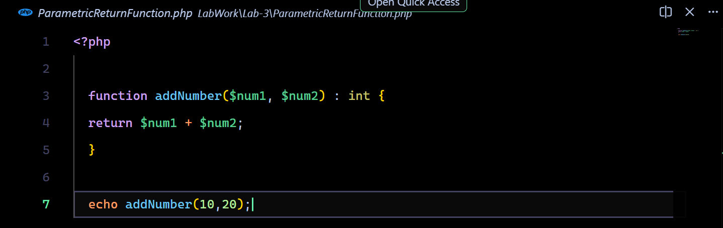
Source Code:


Output:
Layout Modularization

Problem Statement
Create a modular PHP webpage by separating the header, main, contact and footer into different files. Use PHP file inclusion statements.
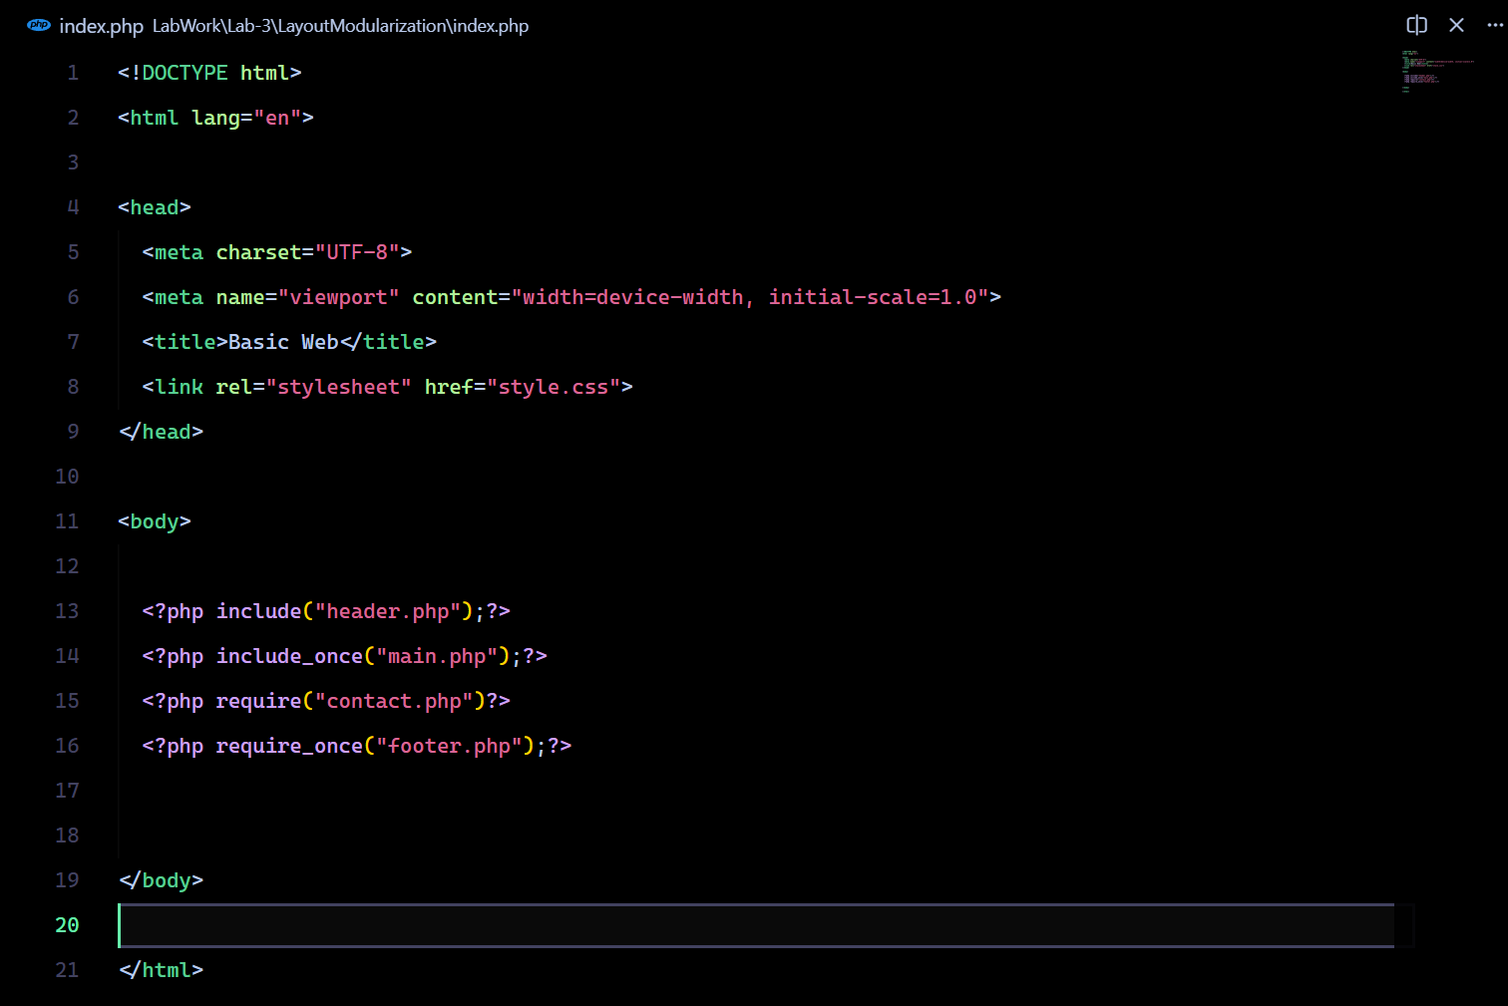
Source Code:
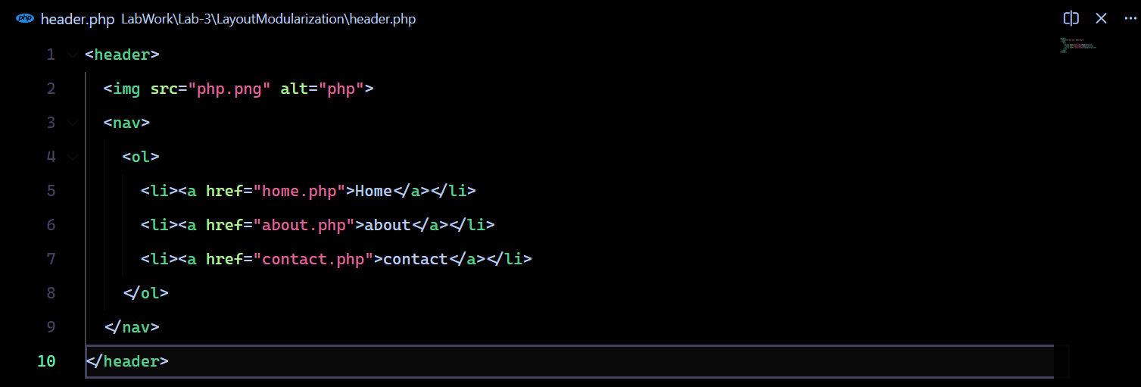
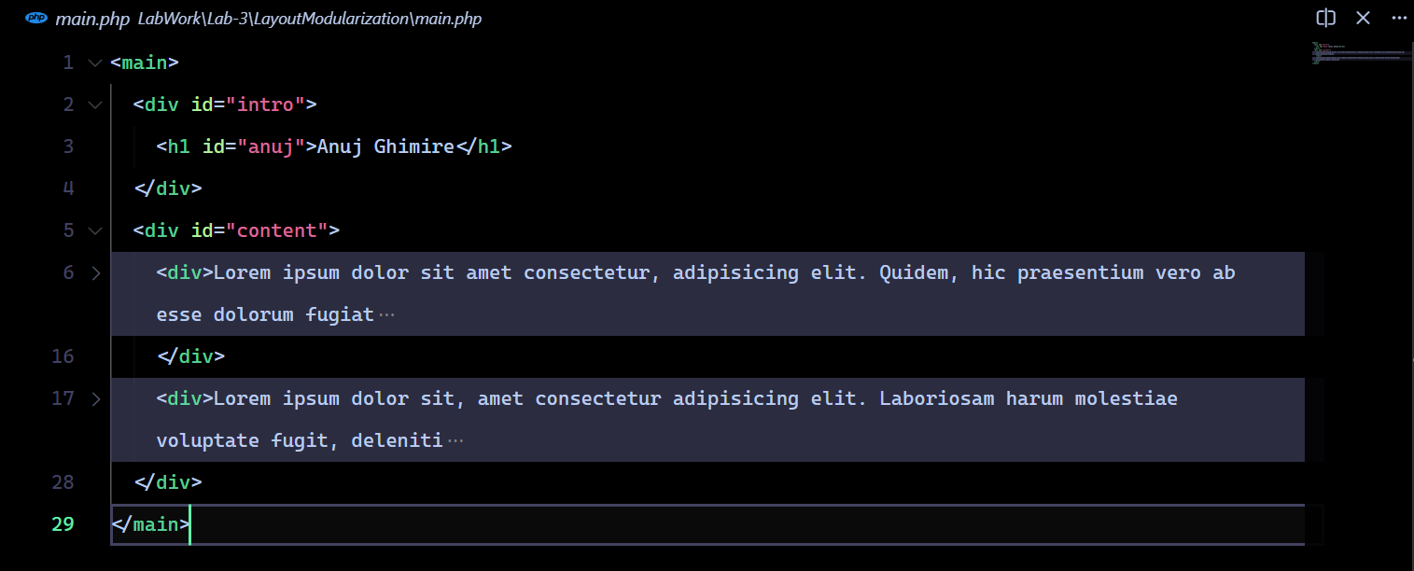
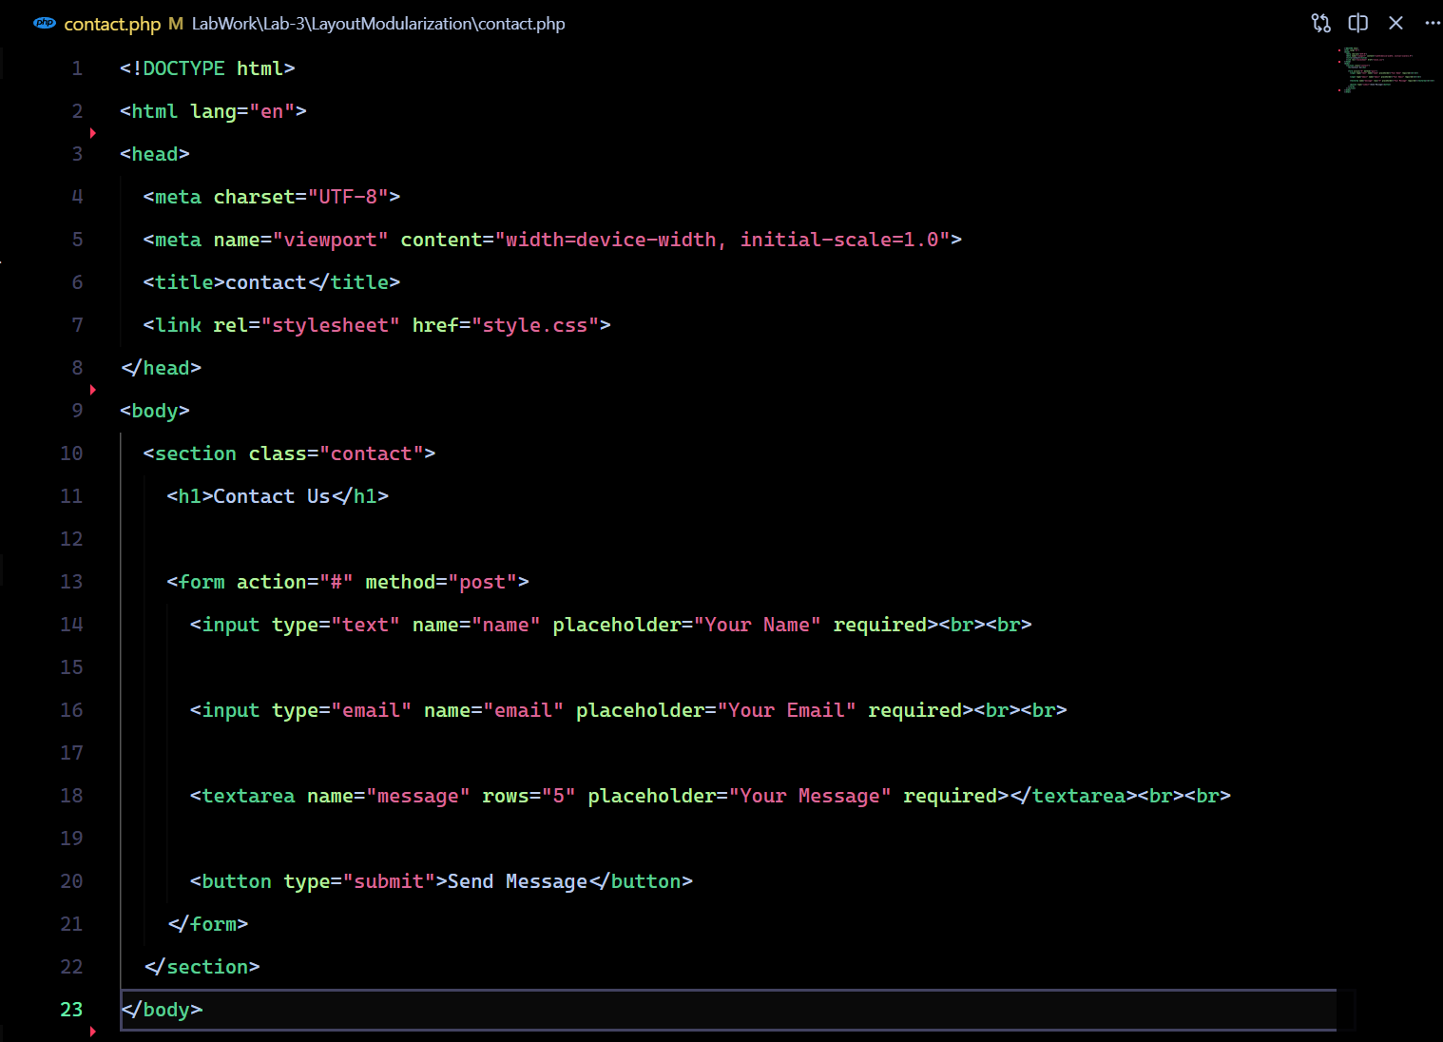
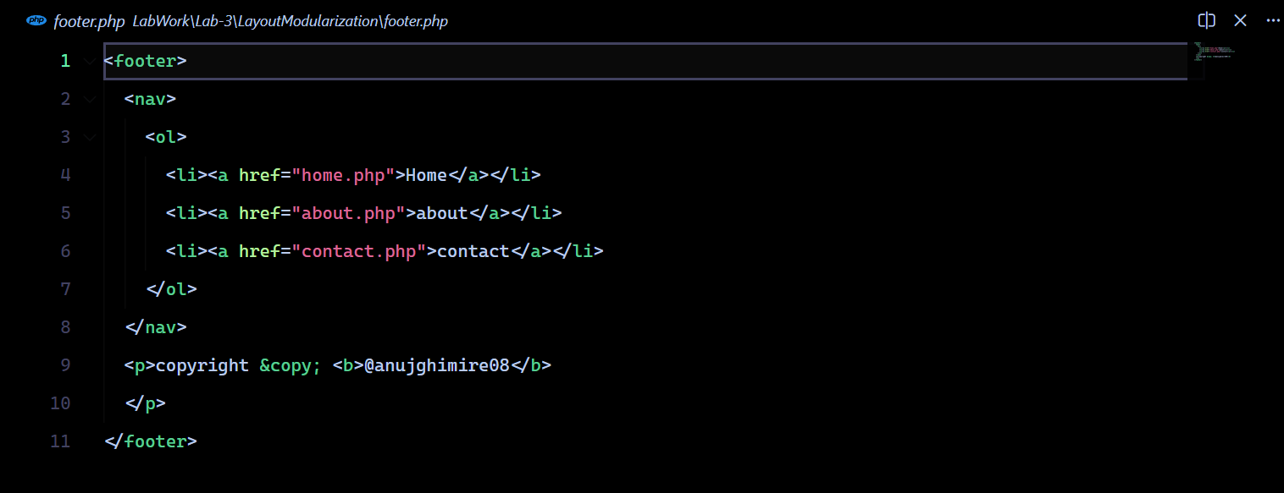

Output:

String Processing Suite

Problem Statement
Write a PHP program demonstrating at least eight string functions.
Source Code:
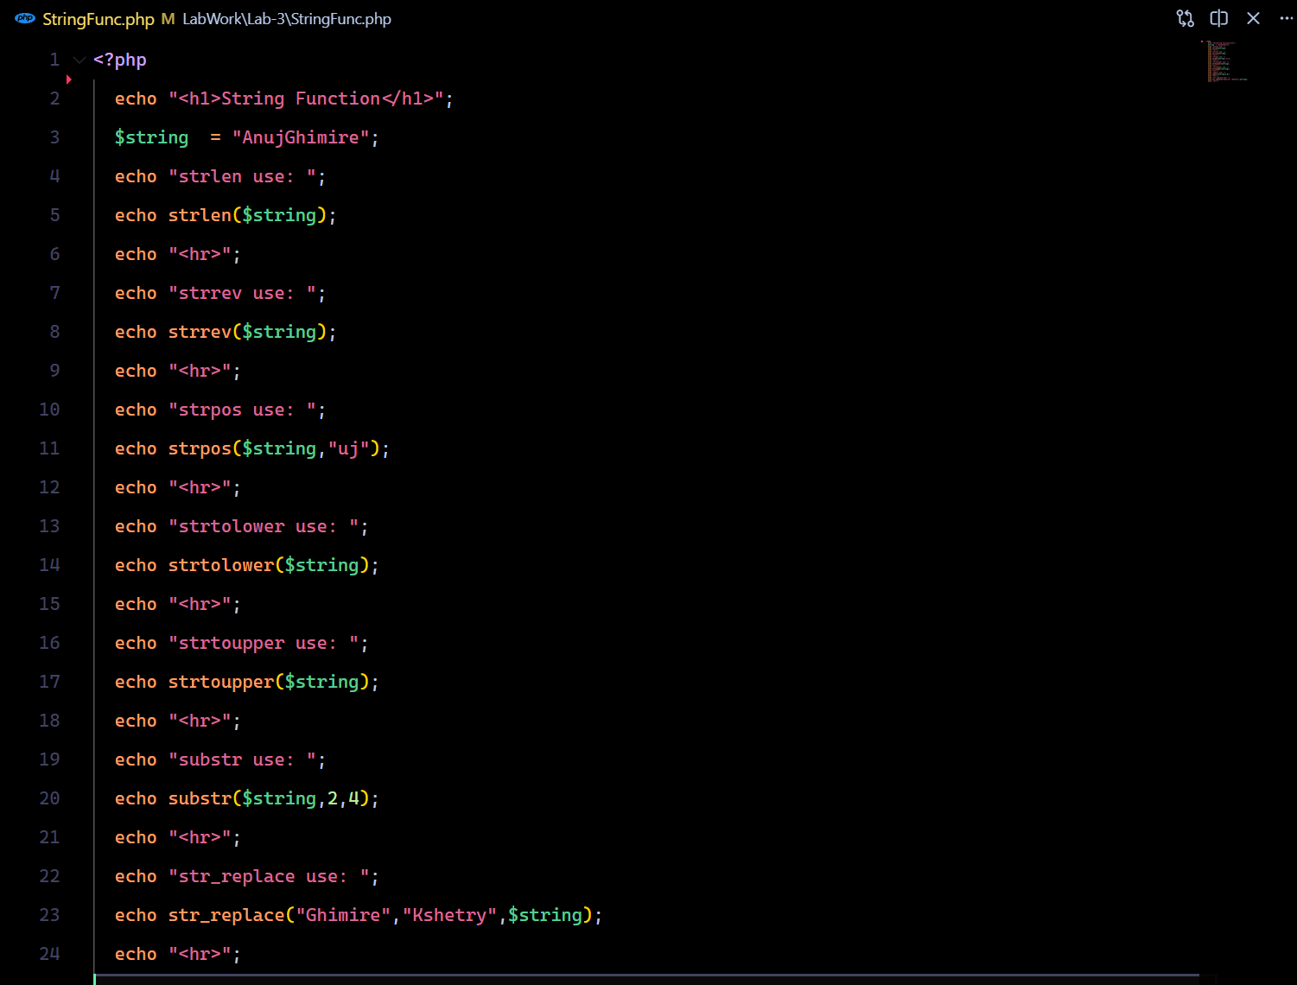

Output:
